**KRISHNA SRINIVASAN**

**BIO-DATA**

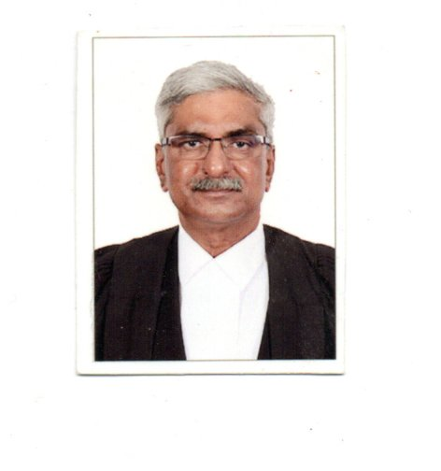

Mr. Krishna Srinivasan, Advocate, born on 12.10.1957, did his schooling in the Rishi Valley School. He earned Bachelor’s Degree in Commerce from Loyola College, Chennai. and then he joined the Madras Law College to read for a Degree in Law.

He enrolled as an Advocate on the rolls of the Bar Council of Tamil Nadu and Pondicherry in the year 1983 and joined a prestigious Firm of Lawyers in Chennai, M/s. King and Partridge.

In the year 1988, Mr. Krishna Srinivasan, along with Mr. Sanjay Mohan, Advocate established the Firm of M/s. S. Ramasubramaniam and Associates, Advocates. The Firm has since gone from strength-to-strength and gained a reputation as one of the leading Firms of legal professionals in the Country.

His fields of expertise as a lawyer span a wide variety of subjects and areas of work and he has appeared in High Courts across the Country and in the Supreme Court.

He is one of the most sought after Advocates in the State of Tamil Nadu and has appeared for several Public Sector Undertakings, MNCs, large Conglomerates and charitable organizations. He has been engaged to appear in many contentious and notable cases, including several high-profile corporate disputes and high-stakes commercial battles.

He has appeared in several matters of significant public interest including cases relating to the Kudankulam Nuclear Power Plant and the Tondiarpet Petroleum Leakage controversies. He spearheaded a hard-fought litigation on the menace of unauthorized constructions in the City of Chennai. He has defended several Hospitals and Doctors in medical negligence matters in the Law Courts and Consumer For across the Country.

For his services as a legal professional over the years, CMC Vellore has conferred upon him the award of “Honorary Fellow of Christian Medical College”. He is amongst the few persons with a non-medical background to have received this singular Honour.

Over the course of a distinguished career spanning 4 decades, he has established himself as one of the leading lawyers in the Country.

In 2023, he was designated a Senior Advocate of the Madras High Court.

Mr. Srinivasan, a long-time resident of Besant Nagar, is a pillar of his community. He is involved in several charitable initiatives and contributes generously to numerous causes.